SCHOOL OF COMPUTER SCIENCE AND ARTIFICIAL INTELLIGENCE |  |  |  |  | DEPARTMENT OF COMPUTER SCIENCE ENGINEERING
Program Name: B. Tech |  |  |  | Assignment Type: Lab |  |  | Academic Year:2025-2026
Course Coordinator Name |  |  |  | Dr. Rishabh Mittal
Instructor(s) Name |  |  |  | Mr. S Naresh Kumar  Ms. B. Swathi  Dr. Sasanko Shekhar Gantayat  Mr. Md Sallauddin  Dr. Mathivanan  Mr. Y Srikanth  Ms. N Shilpa  Dr. Rishabh Mittal (Coordinator)  Dr. R. Prashant Kumar  Mr. Ankushavali MD  Mr. B Viswanath  Ms. Sujitha Reddy  Ms. A. Anitha  Ms. M.Madhuri  Ms. Katherashala Swetha  Ms. Velpula sumalatha  Mr. Bingi Raju
CourseCode |  |  | 23CS002PC304 | Course Title |  | AI Assisted Coding
Year/Sem |  |  | III/II | Regulation |  | R23
Date and Day  of Assignment |  |  | Week10 – Friday | Time(s) |  | 23CSBTB01 To 23CSBTB52
Duration |  |  | 2 Hours | Applicable to  Batches |  | All batches
Assignment Number:20.5(Present assignment number)/24(Total number of assignments)
 | Q.No. | Question |  |  |  |  |  | Expected Time  to complete
 | 1 | Lab 20 – Security Testing: Identifying Vulnerabilities in AI-Generated Code  Lab Objectives:  - Understand how to test AI-generated code for common security vulnerabilities.  - Learn to apply secure coding principles while analyzing AI outputs.  - Practice detecting risks such as SQL injection, XSS, hardcoded credentials, and weak encryption.  - Enhance code reliability and safety by using AI for secure refactoring. |  |  |  |  |  | Week10 - Friday
Task 1 – Password Storage Vulnerability Check
Task:
Analyze an AI-generated signup script for insecure password storage.
Instructions:
- Prompt AI to generate a Python user registration program.
- Check whether passwords are stored in plain text.
- Improve the script using hashing (bcrypt or hashlib).
Expected Output:
- A secure registration script with hashed password storage.
Prompt:-
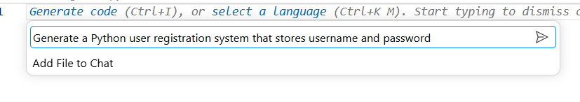
Code;-
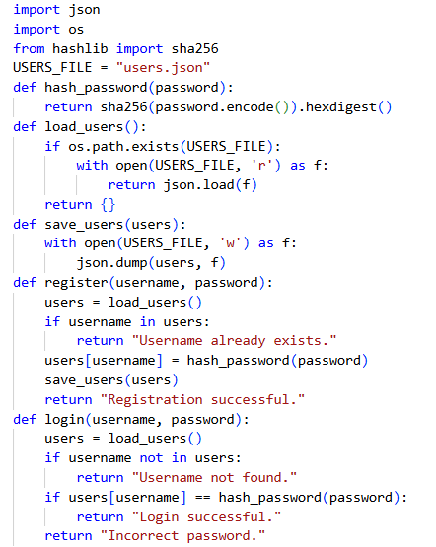
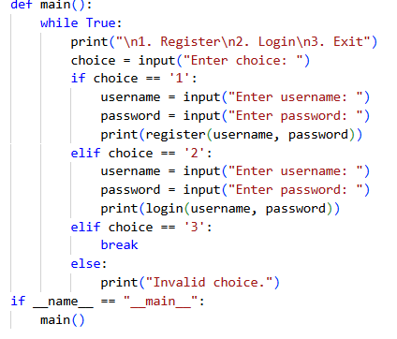

Output:-
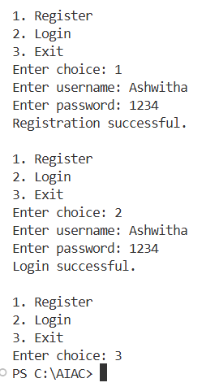
Explanation:-
This task is about checking how passwords are stored in a program. In the insecure version, passwords are saved in plain text, which means anyone who accesses the data can read them easily. This is very dangerous. To make it secure, passwords are converted into a hashed form using functions like SHA-256. Hashing changes the password into an unreadable format, so even if the data is leaked, the original password cannot be easily found. This makes user data more secure.

Task 2 – Hardcoded Secrets Detection
Task:
Evaluate AI-generated code for hardcoded API keys or credentials.
Instructions:
- Ask AI to generate a script that connects to an external API.
- Identify if API keys/passwords are written directly in code.
- Refactor using environment variables or config files.
Expected Output:
- A secure script with secrets managed properly.
Prompt:-
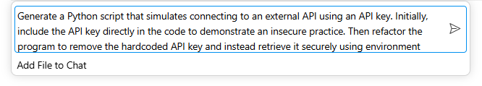
Code:-
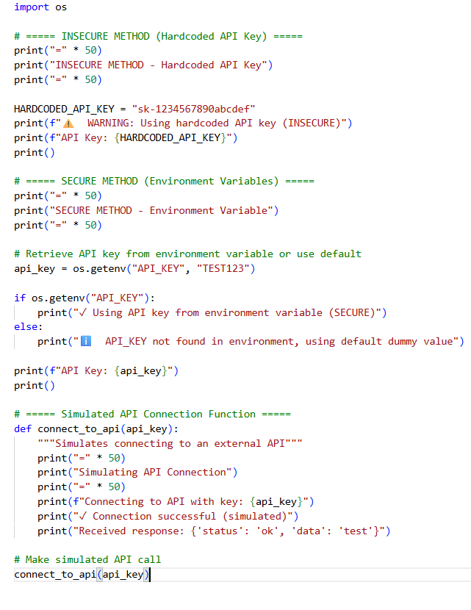
Output:-
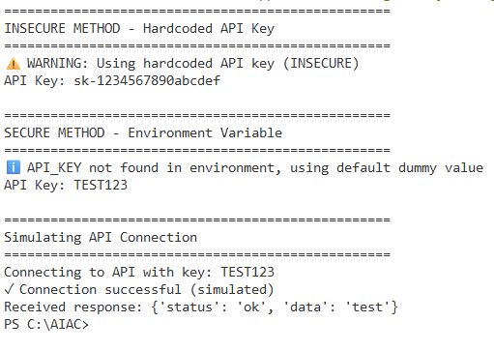
Explanation:-
This task focuses on identifying whether sensitive information like API keys is written directly in the code. Hardcoding secrets is risky because if the code is shared, others can misuse the key. The secure method is to store such secrets in environment variables and access them using os.getenv(). This keeps the sensitive data separate from the code and improves security.

Task 3 – File Upload Security Validation
Task:
Test an AI-generated file upload program for unsafe file handling.
Instructions:
- Prompt AI to generate a Flask file upload example.
- Check for vulnerabilities like uploading executable files.
- Add validation for file type, size, and secure filename handling.
Expected Output:
- A secure file upload implementation
Prompt:-
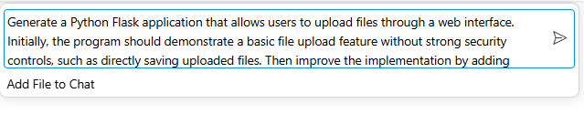
Code:-
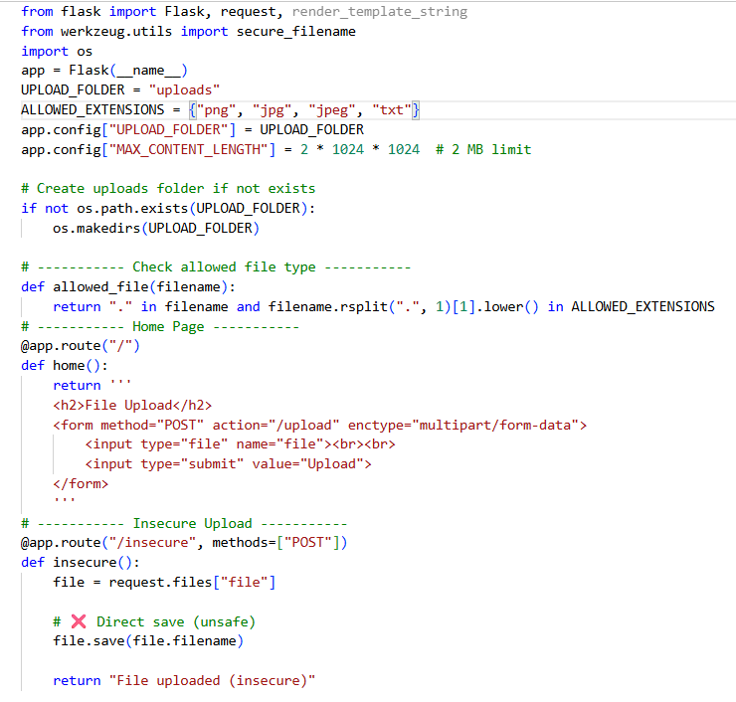

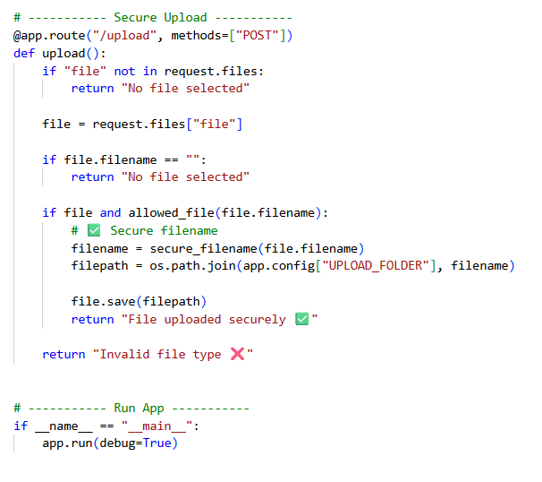
Output:-
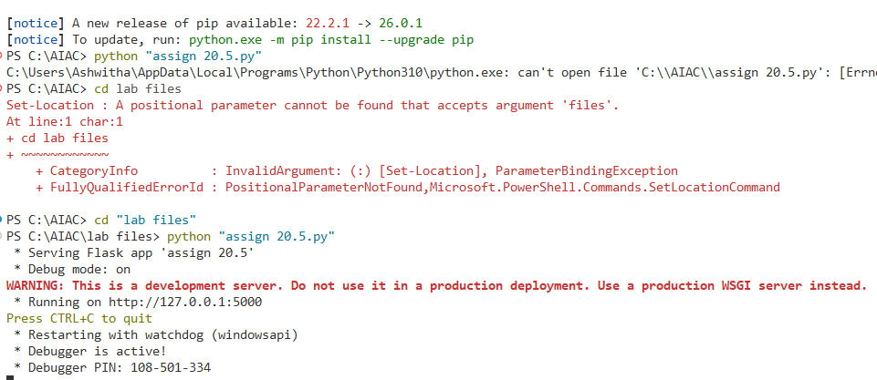
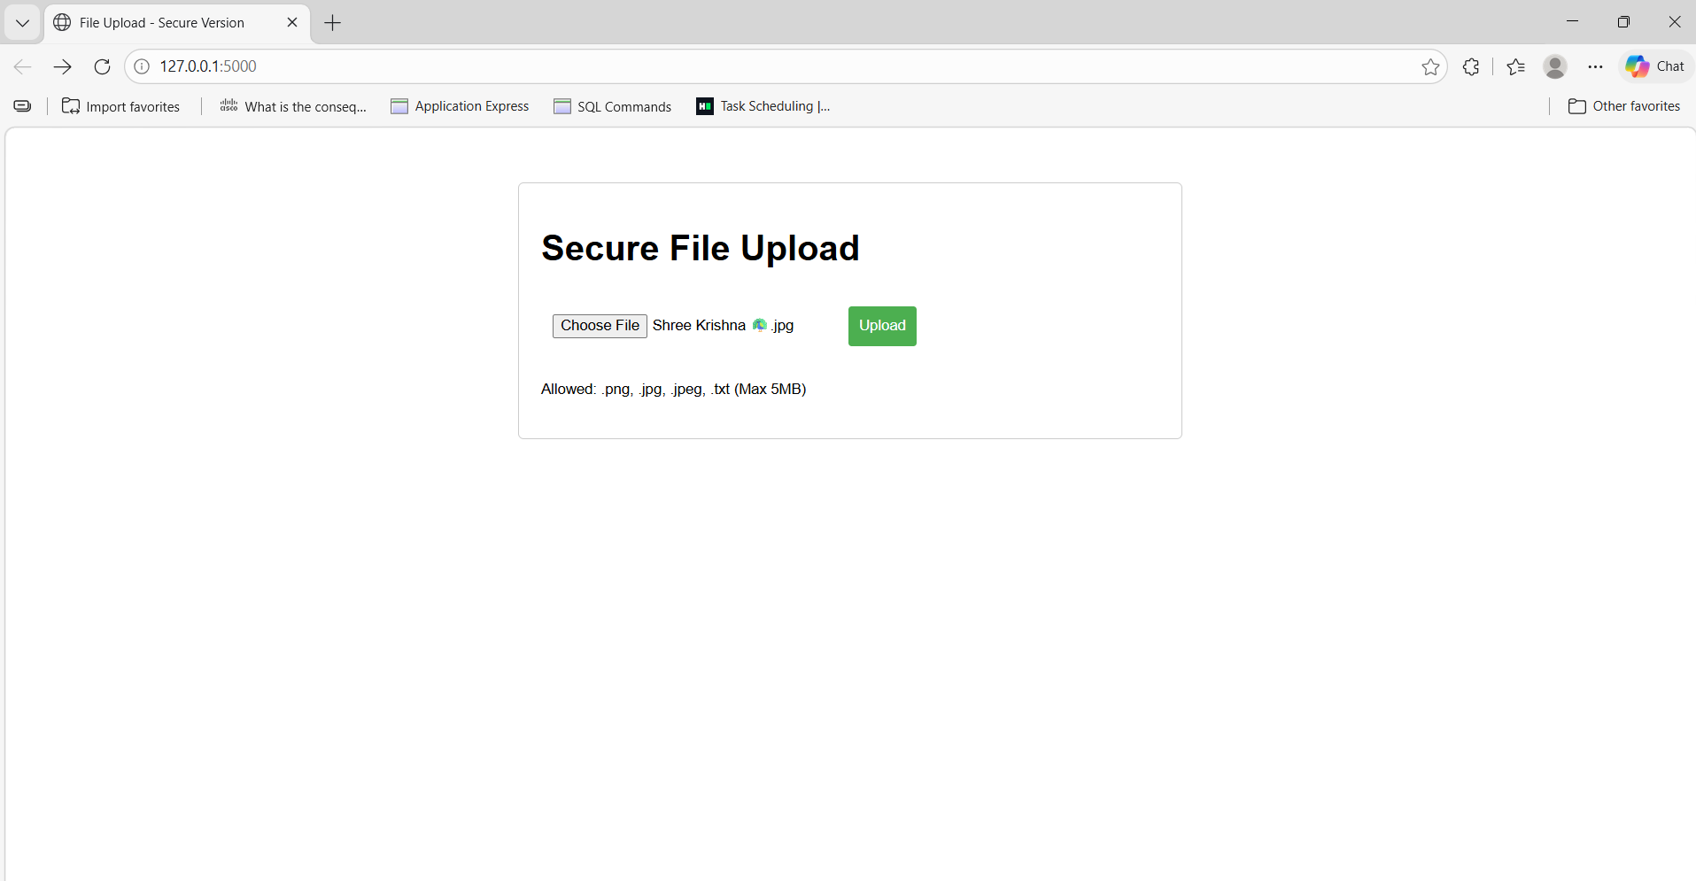
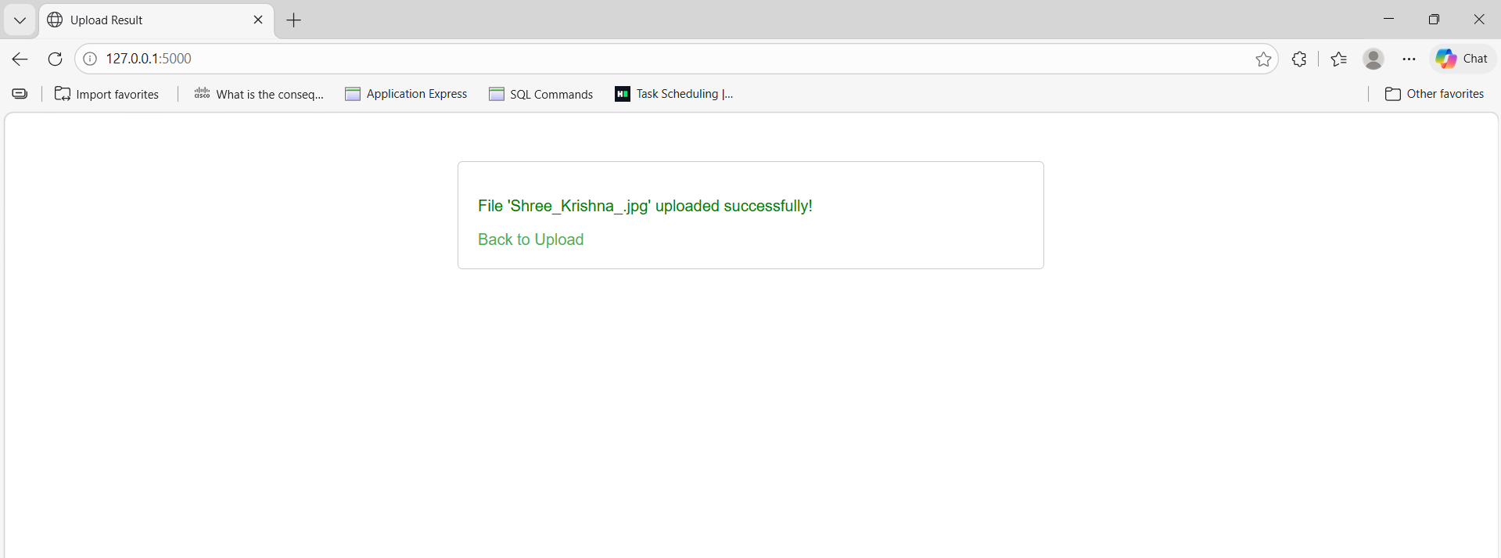

Explanation:-
This task deals with making file uploads safe in a Flask application. In an insecure version, users can upload any type of file, including harmful files. This can damage the system. The secure version restricts file types to safe formats, limits file size, and uses secure_filename() to prevent dangerous file names. These steps ensure that only safe files are uploaded.

Task 4 – Command Injection Prevention
Task:
Analyze an AI-generated Python script that executes system commands.
Instructions:
- Ask AI to generate code using os.system() or subprocess.
- Identify command injection risks with user input.
- Fix using safe subprocess calls and input validation.
Expected Output:
- A secure command execution script.
Prompt:-
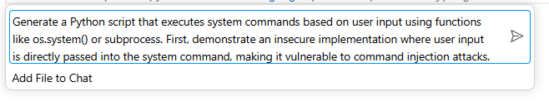
Code:-
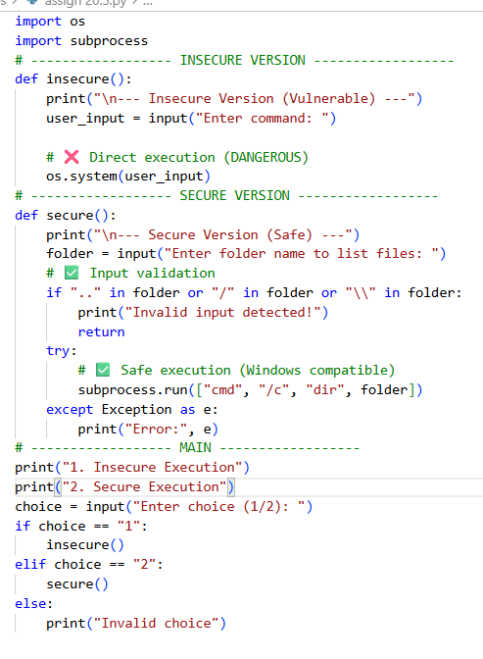
Output:-
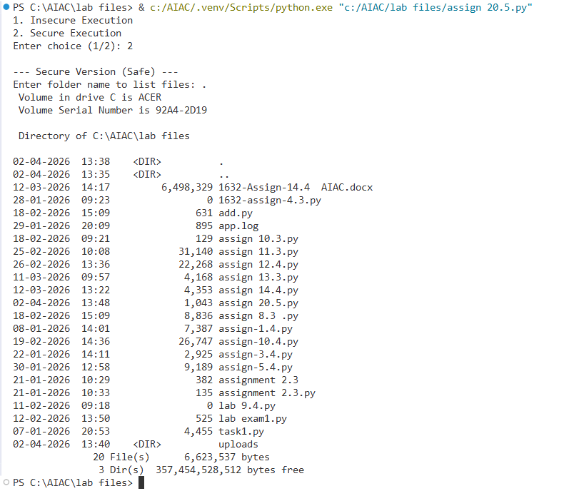
Explanation:-
This task is about preventing command injection attacks. In the insecure version, user input is directly used in system commands, which allows attackers to run harmful commands. This is dangerous. The secure version uses subprocess.run() with proper arguments and validates input to prevent misuse. This ensures that only safe commands are executed.

Task 5 – Secure Input Handling in Web Forms
Task:
Check AI-generated web form code for improper input validation.
Instructions:
- Ask AI to generate an HTML + Flask feedback form.
- Identify missing validation and unsafe rendering.
- Fix using server-side validation and sanitization.
Expected Output:
- A secure form resistant to injection attacks.
Prompt:-
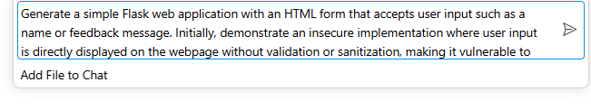
Code:-
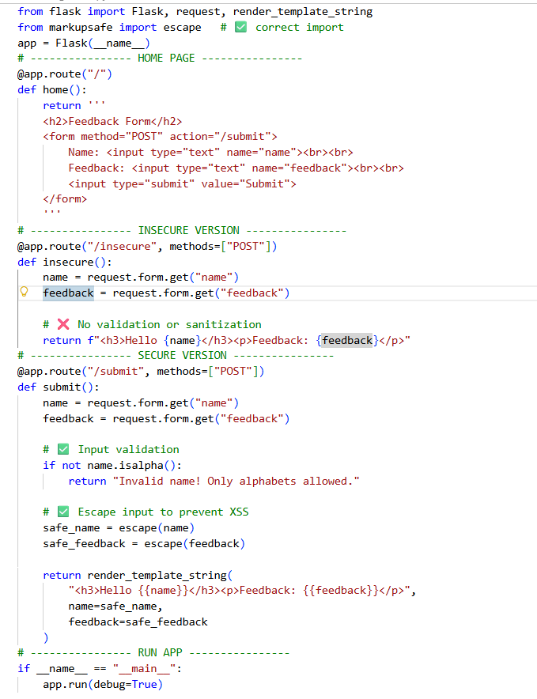
Output:-
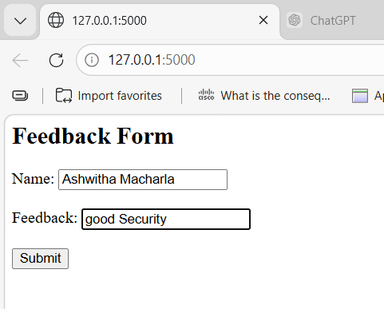
Explanation:-

This task focuses on handling user input safely in web applications. In the insecure version, user input is displayed directly without checking, which can lead to attacks like XSS (cross-site scripting). The secure version validates the input and uses functions like escape() to remove harmful content. This ensures that user input is displayed safely without executing any malicious code.

Note: Report should be submitted as a word document for all tasks in a single document with prompts, comments & code explanation, and output and if required, screenshots.

